WRONG

<div ng-model='selectedCat' ng-repeat="cat in projcatList">

<label>

<a href="" ng-click='groupingProj()'>{{selectedCat.NAME}}****

</label>

</div>

Have nothing coming out

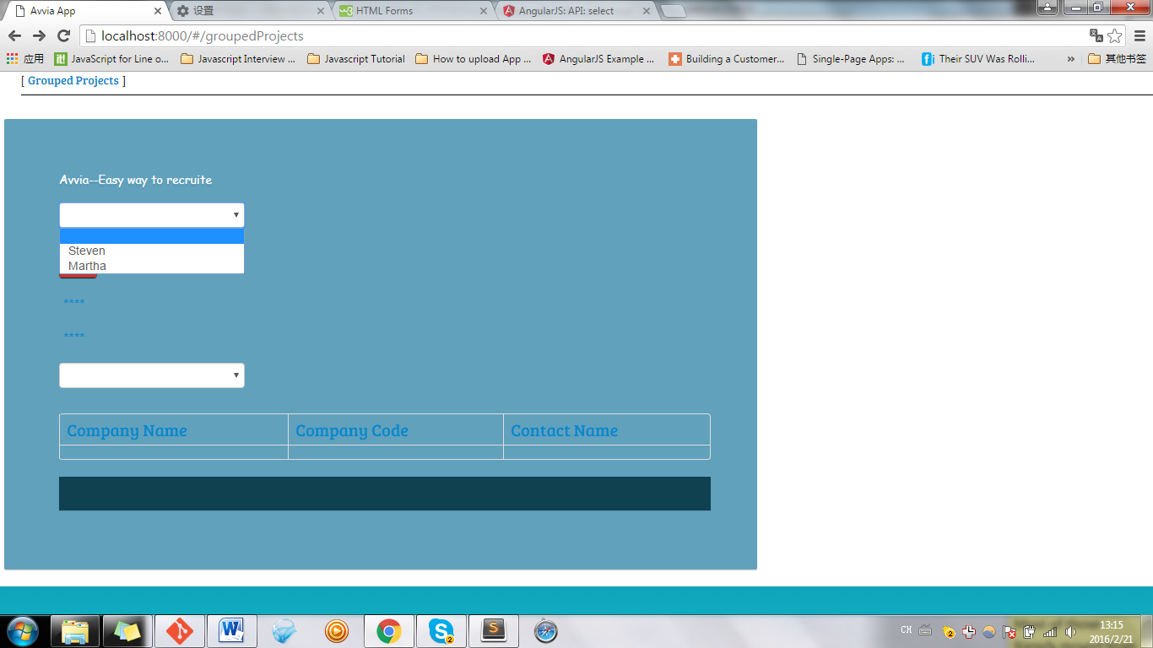

**RIGHT**

**<ul>**

**<select ng-model='selectedCat' ng-options='cat.NAME for cat in projcatList' ></select>**

**</ul>**

**<ul>**

**<input type="button" value="Go " class="btn btn-danger" ng-click='groupingProj()'/>**

**</ul>**

